Scenario 3 - Work Type: Borrower requesting document

Query:
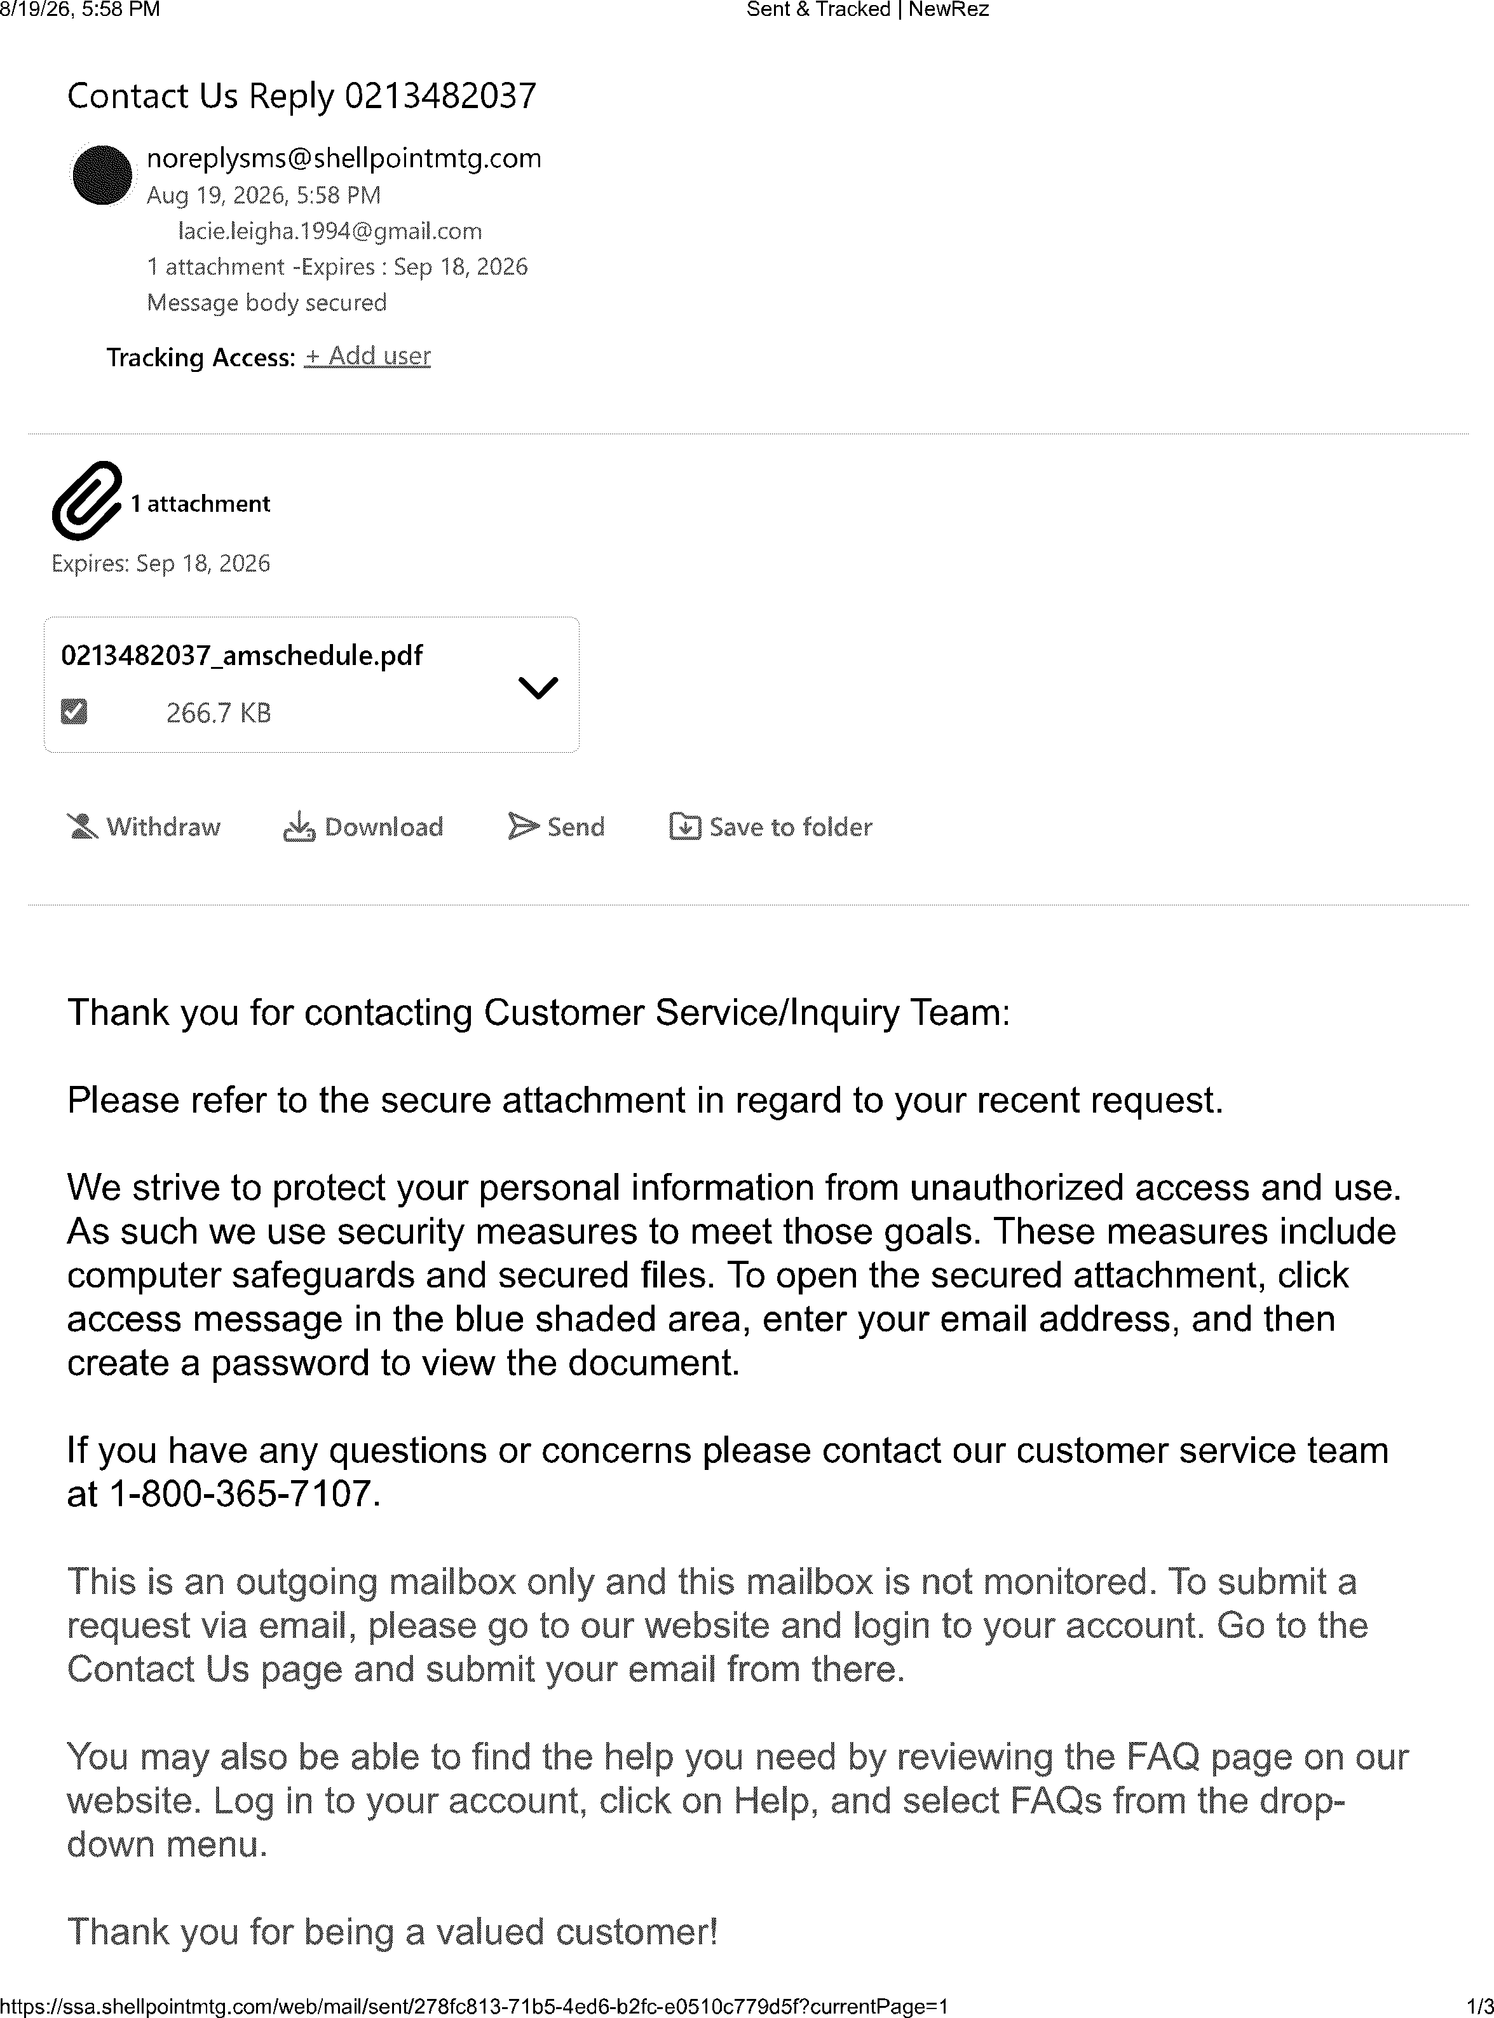
I'm actually requesting a amortization table or schedule for the life of the mortgage. It was not included in my mortification agreement.

Respond send to the borrower:

